We would like to thank the reviewers for their careful reading of the manuscript and highly constructive remarks. We would also like to thank the editors for the opportunity to resubmit our work. We have used the feedback to substantively revise the manuscript. Please find responses to reviewers’ comments below (reviewers’ comments in black, our replies in red).

Reviewers' Comments to Authors
Reviewer D:
Many of us who have an EdD Program are seeking ways to manifest CPED principles in curriculum and pedagogy. In this way, your essay seeks to address significant issues and concerns. The focus of this essay seems more to be about the guiding principles rather than the program design itself, and in that way, adds relatively little to the conversation—given that the guiding principles are in direct alignment with CPED principles. What is lacking in this essay is how you have made manifest connections in your program design with CPED principles by describing how you have implemented those principles in the curriculum/pedagogy. As written, this essay is more aspirational than concrete. What would make this truly informative, would add tremendously to the literature for those of us running EdD Programs would be to be specific about your curriculum. Though your redesigned program has not yet been approved, being specific about the topics, signature pedagogies, and signature projects you have developed for your program would be a great benefit to the field.

Reply: We greatly appreciate the insightful and constructive suggestions. We expanded the essay by describing the signature pedagogies and curriculum that shape our EdD program design. Our manuscript additions and associated page numbers are copied below:

- Our primary objective is to equip scholar-practitioners with the expertise to initiate and sustain systematic approaches to transformative and justice-oriented improvement within their local educational communities, both during and following their time in the program. (p. 1, para 2)

- This essay describes the context, mission, guiding principles, signature pedagogies, curriculum, and anticipated benefits and limitations of our newly designed EdD in Learning and Teaching in Social Contexts. (p. 1, para 2)

- We needed to be in deeper dialogue with our current students, in order to gain a sense of what activism would mean in their local contexts. (p. 3, para 1)

- As a collaborative, relational, and transformative process that is equally shaped by the underlying theoretical perspectives and values with which we approach the pedagogical design of learning, networked learning requires pervasive signature pedagogies that bridge theory and practice (Hodgson, McConnell, & Dirckinck-Holmfeld, 2012). (p. 10, para 2)

- Signature Pedagogies (pp. 10-11)
To support students in their development and testing of theories of action, our program’s signature pedagogies, or “the types of teaching that organize the fundamental ways in which future practitioners are educated for their new professions”, include three dimensions: surface structure, deep structure, and implicit structure (Shulman, 2005, p. 52). While surface structures consist of concrete, operational acts of teaching and learning, showing and demonstrating, and questioning and answering, deep structures reflect a set of assumptions about how to best impart a body of knowledge and know-how (Shulman, 2005). The third dimension, the implicit structure, includes “a moral dimension that comprises a set of beliefs about professional attitudes, values, and dispositions” (Shulman, 2005, p. 55). Throughout the program, faculty will mentor doctoral students through coursework and applied research experiences using a signature pedagogy comprised of three components (Table 1).

Table 1. Three-Component Signature Pedagogy (p. 11)
Component | Scholar-Practitioner Development | Place in Program
Collaborative, Inquiry-Based Learning | - Inquiry as a teaching method seeks to develop inquirers and use curiosity as motivators leading to learning through personal engagement (Justice et al., 2009)  - Inquiry promotes the integration of theoretical and practical knowledge through reflection and dialogue about existing ideals of justice and equity (Lynn & Smith-Maddox, 2007) | - Stage 1: Coursework centering on a Problem of Practice (PoP)  - Interdisciplinary courses prepare students to define and address PoPs
Equity-Driven, Field-Based Research | - Equity-minded practitioners: (1) use data and critical analysis to uncover patterns of inequity student outcomes; (2) are race-conscious and consider the contemporary and historical context of exclusionary practices in America’s institutions of higher education; (3) take personal and institutional responsibility for their students’ outcomes and critically examine their own practices; (4) recognize and understand that inequalities are perpetuated and compounded by the interplay of institutional structures, policies, and practices that are within their control; (5) are accountable to and take responsibility for closing student opportunity gaps (USC, 2020) | - Stage 2: Design and Research Methods for Improving Education  - In combination with Stage 1, methods courses enable students to develop practice-based proposals and initiate opportunities for change in educational contexts
Generative, Transformative Leadership | - Transformative leadership begins with questions of justice and democracy; in practice, educational leaders create inclusive and equitable opportunities that yield generative impacts on learning environments (Shields, 2010)  - Transformative leadership links education and educational leadership with the wider social context within which it is embedded; therefore, transformative leadership and leadership for inclusive and socially just learning environments are inextricably related (Shields, 2010) | - Stage 3: Dissertation in Practice (DiP)  - In combination with Stages 1 and 2, students develop a DiP, or public statement of doctoral quality research, that demonstrates scholarly rigor and practitioner relevance

- Promoting Activism Through Curriculum (pp. 12-16)
Figure 1. Cross-Cutting Program Stages and Experiences (p. 13)

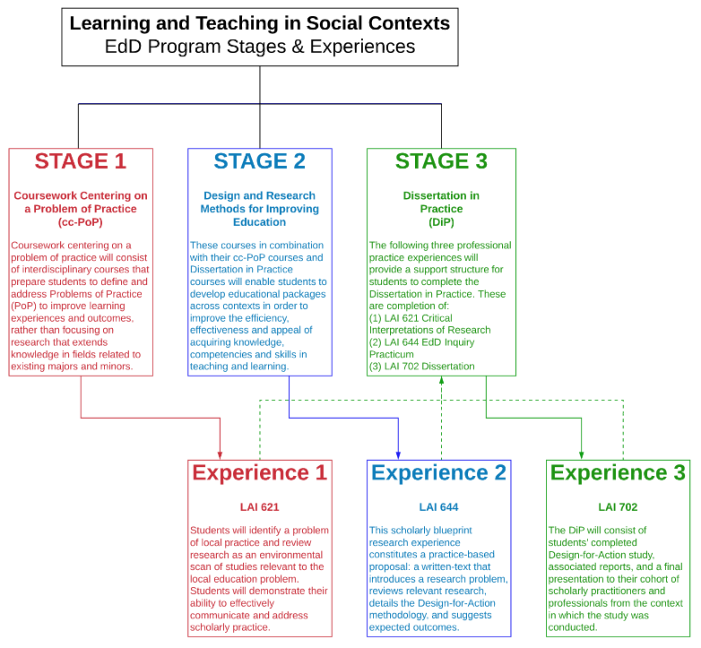

- Throughout the program, students will engage in collaborative, inquiry-based coursework centering on problems of practice and equity-driven, field-based research experiences. Adapted from fellow CPED institutions’ program literature and models (e.g. Florida State University), students’ rigorous preparation will culminate in a Dissertation in Practice (DiP) designed to yield generative impacts and demonstrate each scholar-practitioner’s commitment to transformative leadership within and across educational contexts. Chapter 1 of the DiP will provide a clear articulation of the problem of practice, explanations of the purpose and significance of the study, a description of the study site(s), and research question(s) that are evidently connected to the purpose statement. In their development of Chapter 1, through a lens of equity and justice, students will identify and define a problem of practice using collaborative inquiry, as well as address one or more cultural dimensions of power that are influenced by the proposed problem of practice.
Similar to a review of literature, Chapter 2 will provide a background analysis of previous research related to the problem of practice. While Chapter 2 is expected to begin with a broader analysis of the educational landscape in which the problem of practice is situated, it will also include a description of the study context that connects to a rationale for proposed research and addresses inequitable power structures between communities. Ultimately, Chapter 2 will demonstrate how the problem of practice is informed by: (1) social theories and epistemological frameworks; (2) a critical review of data through multidisciplinary lenses; and (3) a critical review of data across community boundaries.
Chapter 3 is the DiP version of a traditional methodology chapter; that is, the investigative approach designed to answer the research question(s). Chapter 3 will include information that informs questions such as: Which methodological approach(es) were used?; Who and/or what were the data sources and how and/or why were they selected?; Which method(s) of data collection were used?; How were data analyzed?; How were methodological choices evaluated and justified? In their development of Chapter 3, students will defend their use of a design for action that is: (1) situated within theoretical and empirical antecedents; (2) creates generative opportunities for change; (3) seeks to confront and transform status quo practices; and (4) advocates for educational equity in the service of learners.
Lastly, Chapter 4 will provide a focused summary of the entire DiP, including study findings, implications, recommendations for future research, and a dissemination plan that describes how the research will be shared to promote generative impacts and transformative leadership across educational contexts. Upon completion of Chapter 4, students will have argued compellingly that their research: (1) leverages opportunities for the aims of educational improvement; (2) supports the establishment and advancement of networked improvement communities; and (3) addresses a moral, ethical, and political vision that advocates for equity and justice within and across milieus of teaching and learning. An overview of the program exam stages and DiP chapter expectations is provided in Table 2. (pp. 13-15)

- Table 2. Overview of Exam Stages and Dissertation in Practice Chapters (pp. 15-16)
Exam Stage | Required Components | Expected Completion Date
Prequalifying Paper | - 10-page essay  - Problem of Practice statement  - Description of context  - Draft research questions  - Defense of 10-page essay  - Evaluated by advising faculty | - End of Spring 1 (Year 1)  - Summer 2 Week 4
Qualifying Paper | - DiP Chapters 1 & 2 drafts  - Chapter 1: PoP Statement, Purpose, Research Questions  - Chapter 2: Background Analysis (or Review of Literature)  - 2-page methodology overview | - Fall 2 Week 4  - Fall 2 Week 4
Proposal Defense | - DiP Chapters 1 & 2 summary  - DiP Chapter 3 draft  - Pre-recorded 20-minute presentation of DiP Chapter 3  - Chapter 3: Investigative Approach (or Methodology)  - Projected timeline for DiP draft completion  - Organized in consultation with advising faculty  - Synchronous oral defense of items 1-4  - Evaluated by advising faculty | - Complete items 1-5 by End of Spring 2 (Year 2)
Dissertation in Practice | - DiP Chapter 1  - DiP Chapter 2  - DiP Chapter 3  - DiP Chapter 4: Findings, Implications, Recommendations, Dissemination Plan | - Complete drafts of items 1-4 by Spring 3 Week 4
Dissertation in Practice Defense | - DiP Chapter 4 summary  - Pre-recorded 20-minute presentation of DiP Chapter 4  - Executive summary of DiP  - Projected timeline for DiP completion  - Includes revisions recommended by advising faculty  - Organized in consultation with advising faculty  - Synchronous oral defense of items 1-4 | - Final drafts of items 1-5 by End of Spring 3 (Year 3)

Reviewer F:
I think this is a well-written and relevant article. CPED readers are likely to find the program description interesting and useful. The description about your redesign process is compelling because you relied on students' reflections about the current PhD program. I think this article should be published in IE. My question is whether it fits with the activism themed issue. Since you have just redesigned the program, it might be difficult to discuss specifically how the program will promote activism, but perhaps you could include a description of program elements that are intended to do this?
Reply: We greatly appreciate the encouraging comments and thoughtful suggestions. We expanded the essay by describing the program elements that are intended to promote activism, such as coursework centering on a problem of practice, equity-driven design and research methods for improving education, and the culminating Dissertation in Practice. Our manuscript additions and associated page numbers are copied in the preceding replies.

